**Escape From Alcatraz**

**RULES:** Practical Shooting Handbook, Latest Edition **COURSE DESIGNER:** Steve Whittenburg

|  |  |
| --- | --- |
| **START POSITION: See written stage briefings.** | |
| **STAGE PROCEDURE**  Engage targets from within the shooting area. | **SCORING**  **SCORING:** Comstock 22 rounds.  **TARGETS:** 11 cardboard  **SCORED HITS:** 2 Best hits per carboard will be scored  **START-STOP:**  Audible - Last shot  **PENALTIES:** Mike -10, NS -10, Procedural -10 |

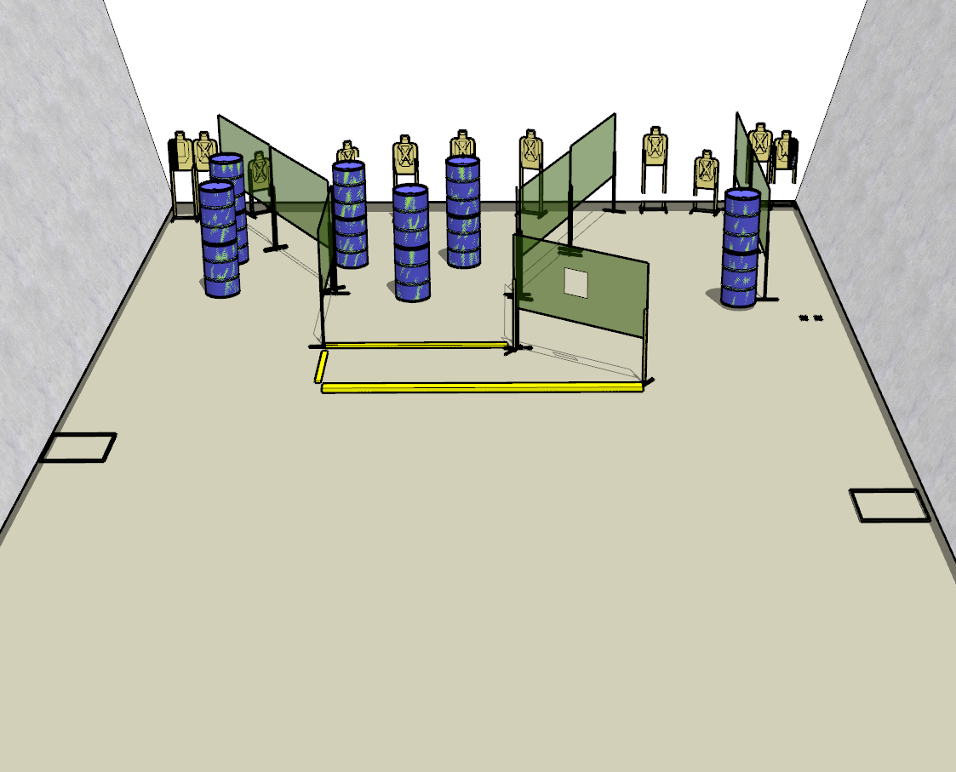

**Written Stage Briefings:**

**Stage 1 –** is a 22-round, 110 point, Comstock Long Course. There are 11 cardboard targets. The best 2 hits per cardboard target will be scored.

**Handgun start position** is standing with toes on rear of left shooting box, facing downrange. The handgun is **unloaded** and holstered.

**PCC start position** is standing with toes on rear of left shooting box facing downrange. PCC is **unloaded** with buttstock on belt with muzzle pointed downrange.

On the audible start signal, engage targets from within the shooting area. **You must make a mandatory reload before your final shot is fired.**

**Stage 2 –** is a 22-round, 110 point, Comstock Long Course. There are 11 cardboard targets. The best 2 hits per cardboard target will be scored.

**Handgun start position** is standing anywhere inside the center shooting area, facing downrange. The handgun is **loaded** and holstered.

**PCC start position** is standing anywhere inside the center shooting area facing downrange. PCC is **loaded** with buttstock on belt with muzzle pointed downrange.

On the audible start signal, engage targets from within the shooting area.

**Stage 2 –** is a 22-round, 110 point, Comstock Long Course. There are 11 cardboard targets. The best 2 hits per cardboard target will be scored.

**Handgun start position** is standing with both feet on the Xs, facing downrange with wrists above shoulders. The handgun is **loaded** and holstered.

**PCC start position** is standing with both feet on the Xs facing downrange with wrists above shoulders. PCC is **loaded** with muzzle pointed downrange.

On the audible start signal, engage targets from within the shooting area.